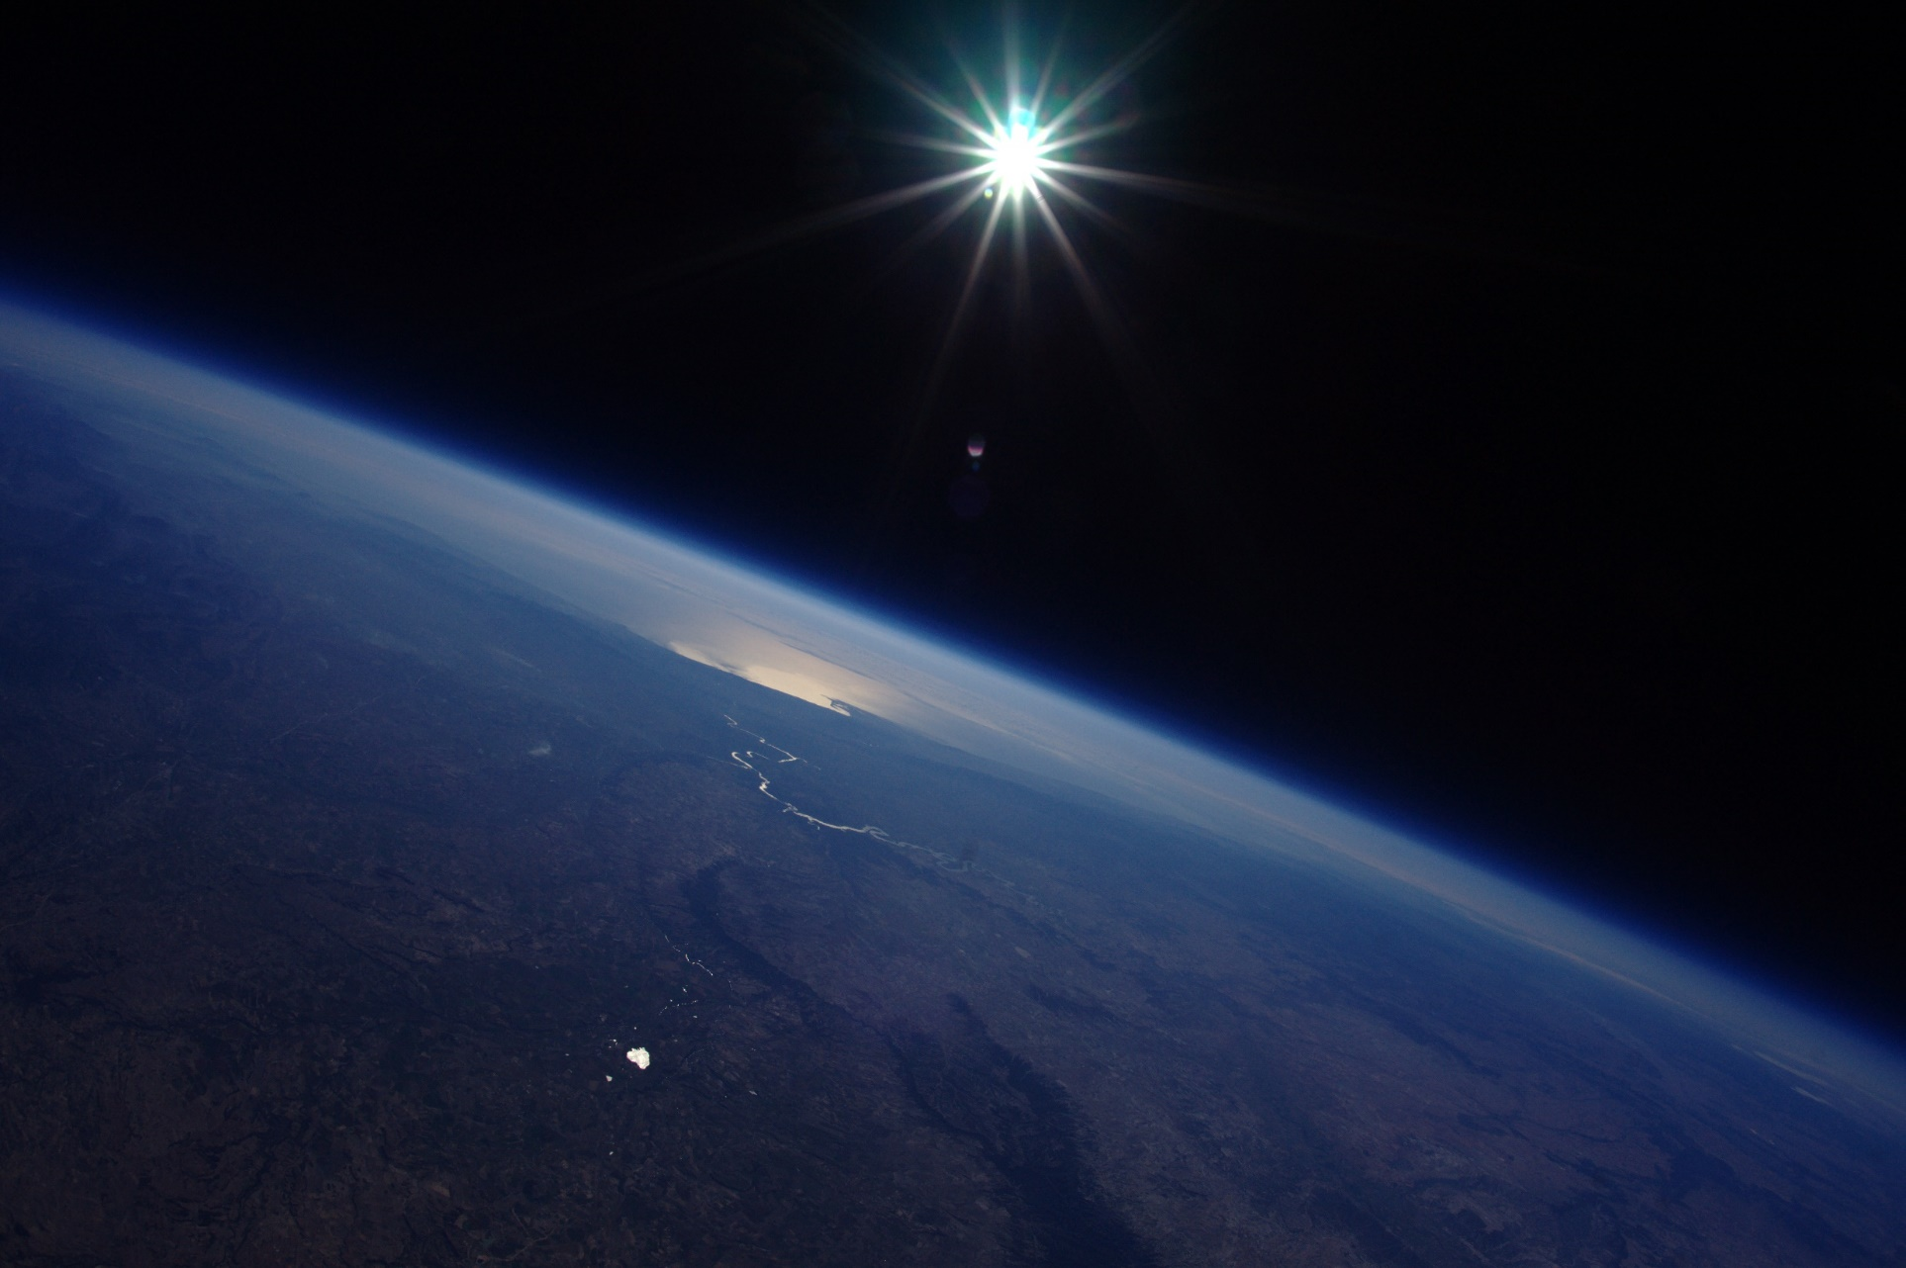

qbcan

OPEN COSMOS

**“Aim high, go beyond”**



tHE vision

At Open Cosmos Ltd we are committed with the development of simple and affordable technology that allows entrepreneurs, researchers and organizations to develop, test and deploy space assets.

We believe that getting our technology at the service of the next generation of space engineers will make them realise how easy it can be to develop space technologies and empower them with a priceless can-do attitude. Our educative and young professional products are designed around three major concepts:

|  |  |  |
| --- | --- | --- |
| **Open Source** | **Simple** | **Affordable** |



|  |  |  |
| --- | --- | --- |
| * Allows in-depth understanding * Promotes innovation and collaboration * Allows modifications and upgrades | * Intuitive learn-by-doing electronics * Detailed instructions * Developer’s community | * Money should not be a game stopper * You should be able to repair it yourself in case of damage. |

CanSat is the perfect platform to teach how to design, test and fly basic space technologies. Providing a bus standard would allow students to focus on more challenging payload development.



the product

**qbcan** is a standard CanSat bus build from open source electronics and designed to host a wide range of customisable payloads. It comes with a basic webapp that allows the developer to test and monitor the integration of customised payloads.

|  |  |  |
| --- | --- | --- |
| **Hardware**  **(qbcan)** | **Software**  **(qbapp)** | **Community and user’s guide** |

|  |  |  |
| --- | --- | --- |
| CanSat bus:   * Standardized bus with Plug&Go interfaces * ¾ of the CanSat available for payload * Open Source electronics | Web app that allows:   * Easy coding and interaction with the bus. * Payload monitoring and customisable ground integration and testing. | Open Cosmos online:   * Our detailed user’s guide boosts your start. * Our Open Cosmos community shares knowledge to leverage innovation. |

Having an open source standard bus allows students to have a solid first step and upgrade its capabilities and/or develop customised payloads. Our software paths their way when integrating new payloads and the Open Cosmos Community will always be there to help.



the product

Technical features

User guide



the add-ons

Two main products complement qbcan: a ground station and a launcher.

### GROUND STATION

Open Cosmos has developed a ground station optimised to receive data form our cansat standard. This would allow developers to test their communications in the same conditions that they would experience through a cansat competition. The yagi antenna can be manually pointed towards qbcan or automatically if the cansat carries a gps tracker.

Tech features

### CANSAT RELEASER

In order to release cansats Open Cosmos has set a lighter than air platform that allows to rise two cansats up to 300m and deploy them one by one. The platform can be tethered or operated in movement.

It has both an up and down link which allows the CanSats to be released on demand from the ground, as well as a tracking and control system that ensures

Tech features



The customer



the user

**qbcan** is designed for educative purposes targeting students from high-school to university as well as space enthusiasts willing to experience what it is like to design, build and fly a spacecraft like system.

To meet its divulgative purpose we have made it as affordable as possible, building it from modular electronics easy replaceable in case of damage. The list of components, electronic blue prints, CAD 3D printable structure, and an up-to-date detailed User’s Gide will be open and available at [www.open-cosmos.com](http://www.open-cosmos.com). Developers with a free membership registration will be able to ask for advice, collaborate and share knowledge with other members of the Open Cosmos community.

Open Cosmos shares **ESA**’s vision to bring space technology closer to people and engage young engineers in its development.



x



the TEAM

## MANAGEMENT TEAM

|  |  |  |  |  |  |  |
| --- | --- | --- | --- | --- | --- | --- |
| mr. Rafael jordá Siquier fOUNDER |  | PhD. josep virgili llop FOUNDER | |  | mr. jordi barrera ars MR. RICARD VILA RODRIGUEZ | |
| http://www.trademarkia.com/logo-images/urdiales/0-zero-2-infinity-77747872.jpglogo-UPC.gifEF-Education-First |  |  | |  | logo-UPC.gif  in july 2007 the boston consulting group put out a report grandly ... | |
| **Tel** +34 687127844  [rafel@open-cosmos.com](mailto:rafel@open-cosmos.com)  [es.linkedin.com/in/rafaeljorda](https://es.linkedin.com/in/rafaeljorda) | |  | **Tel** + 687728401  [josep@open-cosmos.com](mailto:josep@open-cosmos.com) [www.linkedin.com/in/JosepVirgili](http://www.linkedin.com/in/JosepVirgili) | |  | **Tel** +41 7462 38369226  [jordi@open-cosmos.com](mailto:jordi@open-cosmos.com) [ricard@open-cosmos.com](mailto:ricard@open-cosmos.com) |

At the moment we are under several incubator programs and public grant applications pursuing the initial investment to start the business.

We are building a solid team based on shared values: innovation, commitment and motivation.

